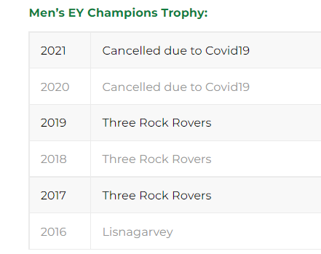
Do join us at Grange Road next Saturday 25th July when the 1sts play Annadale. Match at 3.30pm. This is last match before they represent Ireland in Europe.
TRR are off to a good start in EY with wins over UCD and Banbridge.
However, it has not been plain sailing with many of previous season’s players leaving.
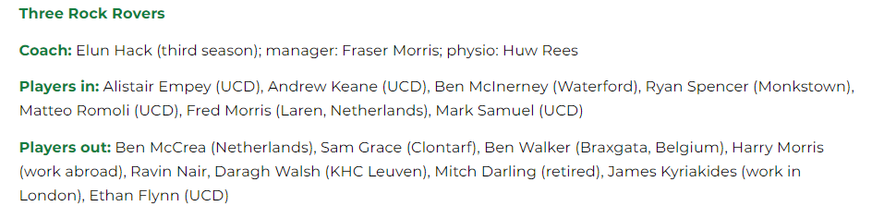
For spectators, I commend Stephen Findlater’s profile of TRR and other Clubs on the Hockey Ireland website
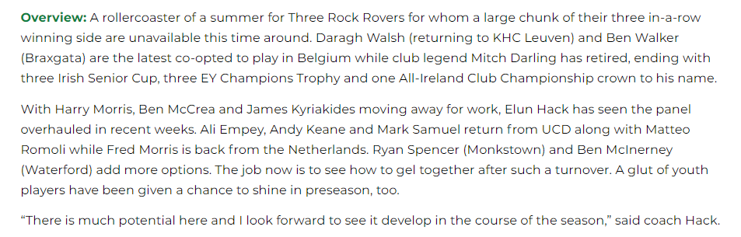
https://hockey.ie/?search=profile; & https://hockey.ie/competitions-2/eyhl/ &

Three Rock Rovers 3 (B Pasley, B Johnson, R Canning) Banbridge 1 (J McKee)
Three Rock Rovers made it two wins from two as they produced a strong defensive performance to get the best of the visiting Banbridge at Grange Road.
Bann made most of the early inroads with Jonny McKee hitting the post two minutes into the game before breaking the deadlock 15 minutes in with a back post deflection.
Rovers, though, responded in kind with their first shot in anger as Ben Johnson scored a corner flick to make it 1-1 at the end of Q1. Ben Pasley then finished off an excellent counter goal to put the hosts in front and it remained 2-1 until half-time with Harry MacMahon saving a Philip Brown shot off the line.
For Bann, they were frustrated they could not do more with eight corner efforts – not helped by Brown’s departure with a concussion – as Ben Whelan and his defensive team were able to rebuff those attacks. And the result was sealed in the third quarter when Ryan Spencer’s turnover laid on the chance for Ross Canning to score with a first-time finish.

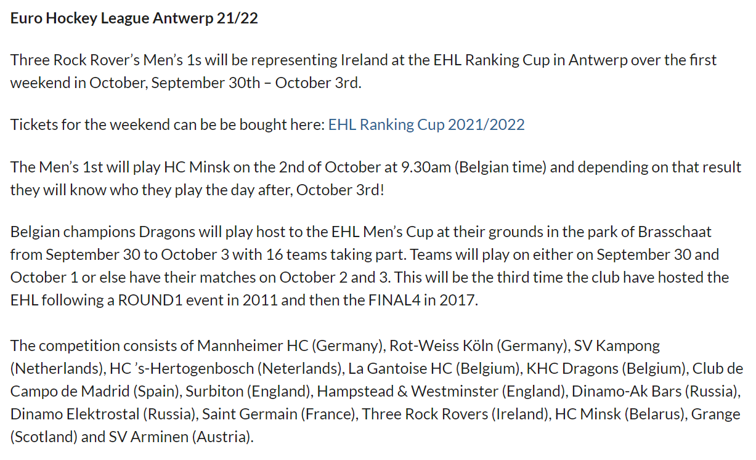

Source: TRR Newsletter. Email the Club so get your email added to TRR Newsletter circulation list.
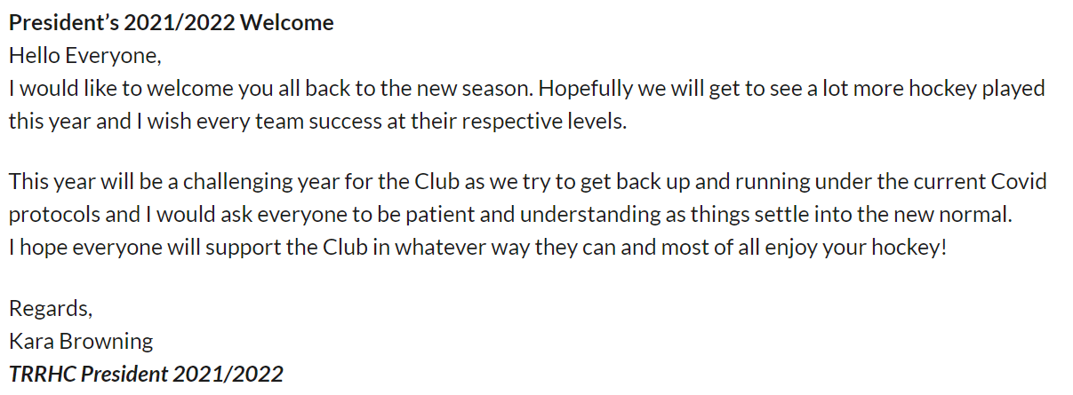

Pavilion membership
While an enormous number of former playing members, delight in the ongoing successes of the Club, very few take time to pay the Pavilion member subscription of just 50 euro per annum. Most of the membership pays online. We accept cheques.

These notes cut and pasted by John Findlater; john.findyoulater@gmail.com

Paying sub online:
Already registered
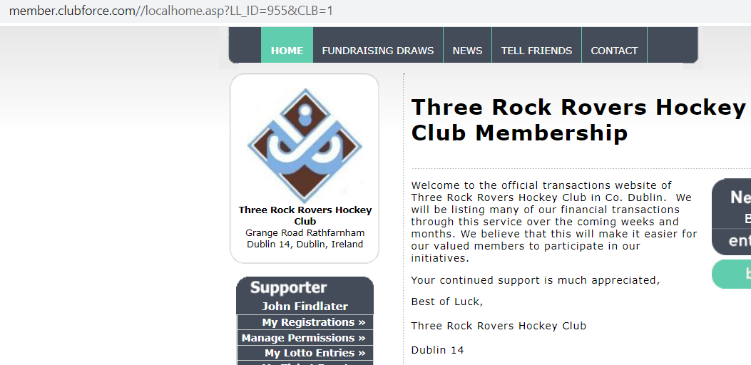

https://member.clubforce.com/memberships_cart

